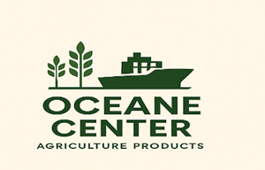

# PROFESSIONAL PRODUCT CATALOG

## OCEANE CENTER

## 🌍 Company Profile

**Name: OCEANE CENTER**  
Specialty: Production and Export of Agricultural Products from Benin  
Location: Abomey-Calavi, Cotonou, Benin  
Contact:  
- WhatsApp: +229 01 58 18 85 52  
- Email: [supremeetfils@gmail.com](mailto:supremeetfils@gmail.com)

- RCCM: Cot N° RB/ABC/23 A 95630

- IFU: 0202326060268

## 📦 Our Available Products

### 1. Cassava Flour (Gari)

- Quality: Naturally dried, no additives  
- Packaging: 100 kg bags  
- Shelf life: 12 months  
- FOB Price: Starting from 95 USD per bag

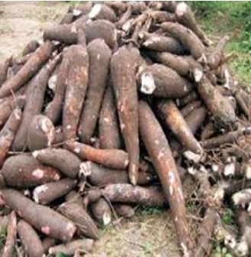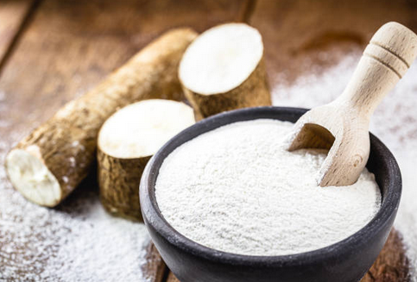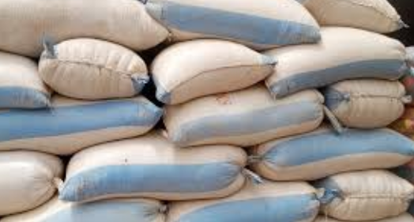

**2. Fresh Coconuts**

- Category: Large size, Benin origin  
- Packaging: Bags of 50 pieces or as requested  
- Shelf life: Up to 60 days  
- FOB Price: Upon request

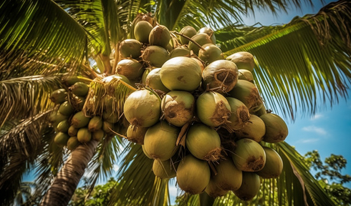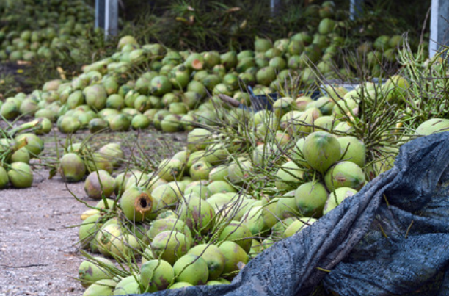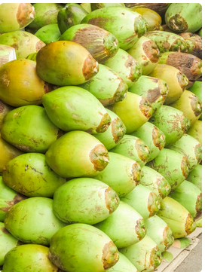

### 3. Charcoal

- Type: Hardwood, long-burning  
- Packaging: 20 kg bags or customized  
- FOB Price: Starting from 55 USD per bag

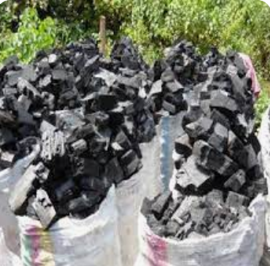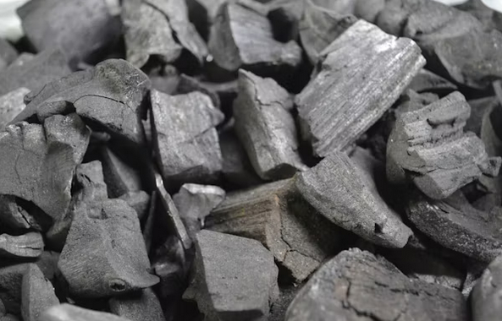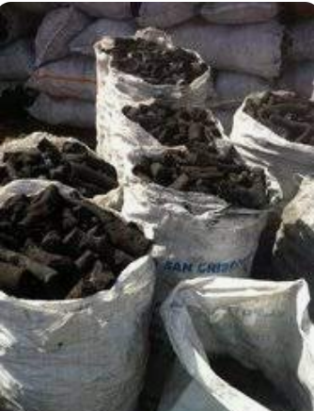

### 4. Crude Palm Oil

- Extraction: Traditional method, cold-pressed  
- Packaging: 25 L drums / 200 L barrels  
- Shelf life: 12-18 months  
- FOB Price: Starting from 70 USD per bag

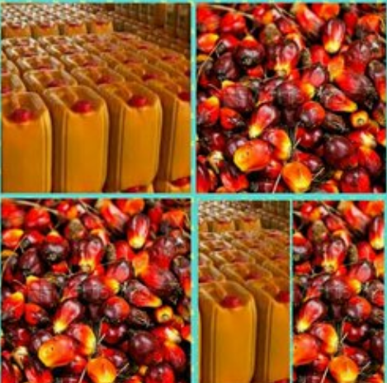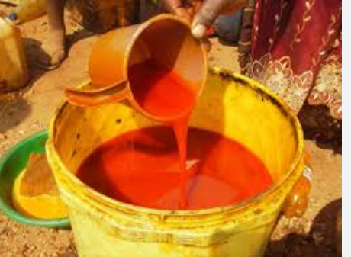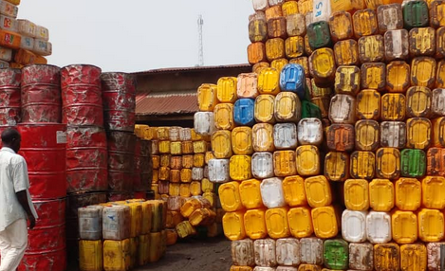

### 5. Raw Cashew Nuts

- Quality: High-grade raw cashew nuts, Benin origin  
- Packaging: 80 kg bags or as requested  
- FOB Price: Upon request

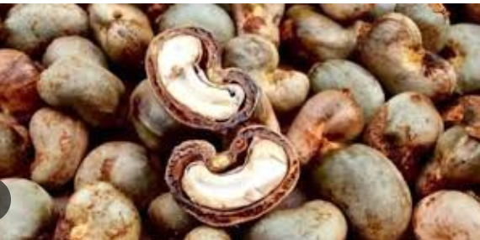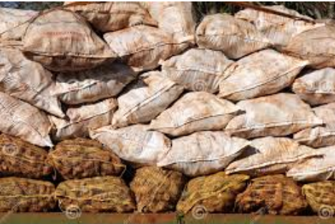

### 6. Soybeans

- Quality: Non-GMO, high protein content  
- Packaging: 50 or 100 kg bags or as requested  
- FOB Price: Upon request

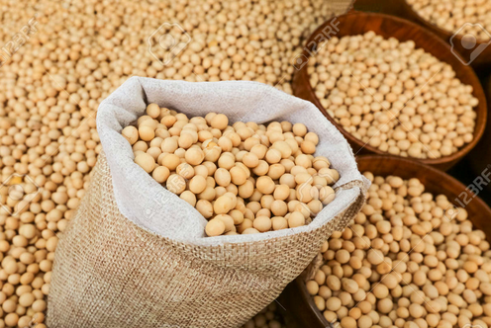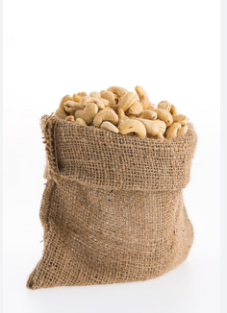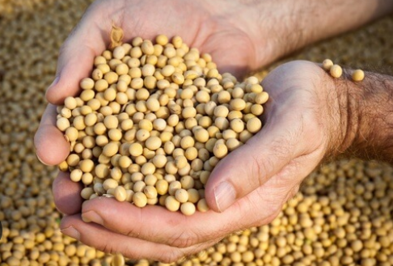

### 7. Raw Cocoa Beans

- Quality: Naturally fermented, premium grade  
- Packaging: 60 kg bags or as requested  
- FOB Price: Upon request

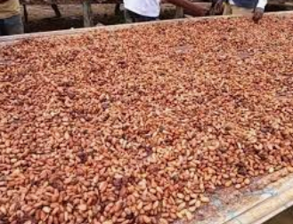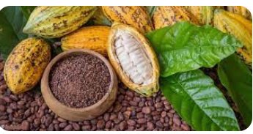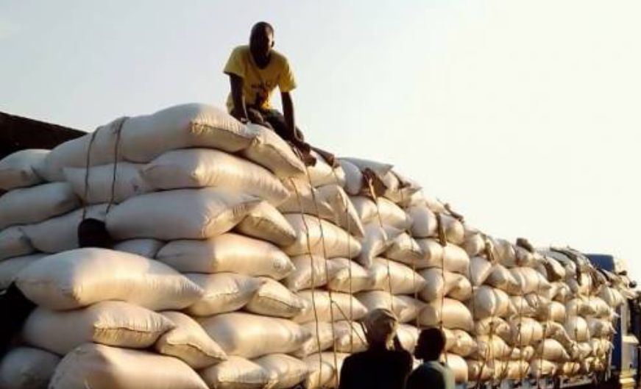

## ✨ Competitive Advantages

- High-quality products  
- Mastery of export procedures  
- Capacity to deliver in large quantities  
- Flexible incoterms (FOB, CIF)  
- Fast delivery times

## 📞 Quick Contact

**For orders or additional i**nformation, please contact:  
Thierry ADJIVEHOUN  
Founder - OCEANE CENTER  
WhatsApp: +229 01 58 18 85 52  
Email: supremeetfils@gmail.com  
  
We are open to sustainable and reliable international partnerships.